**Netflix-Clone Reactjs**

**Netfllix Clone Using Reactjs**

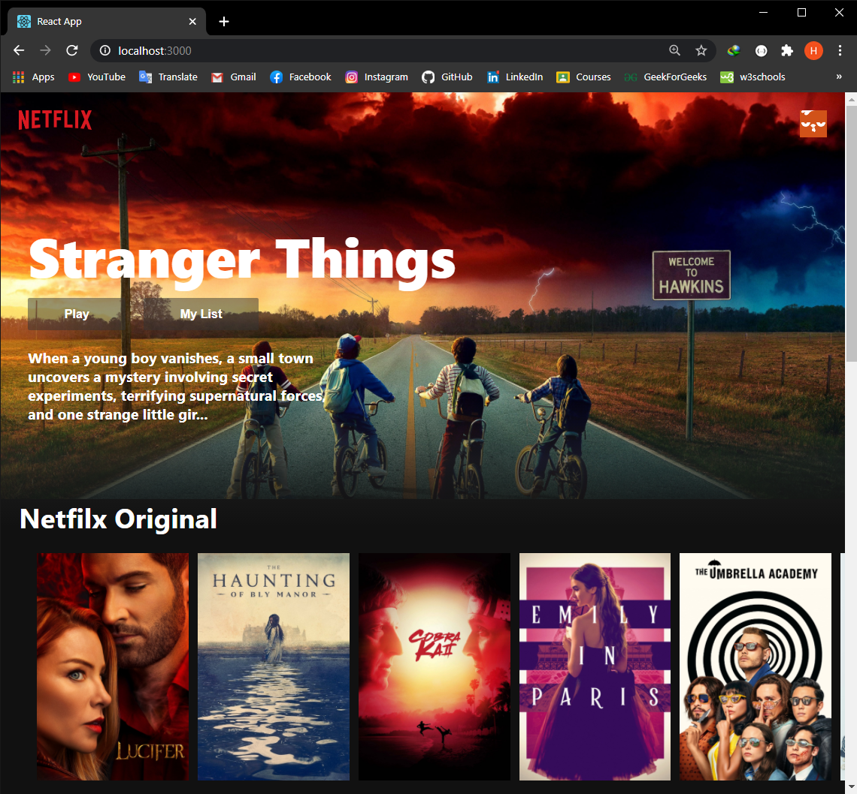

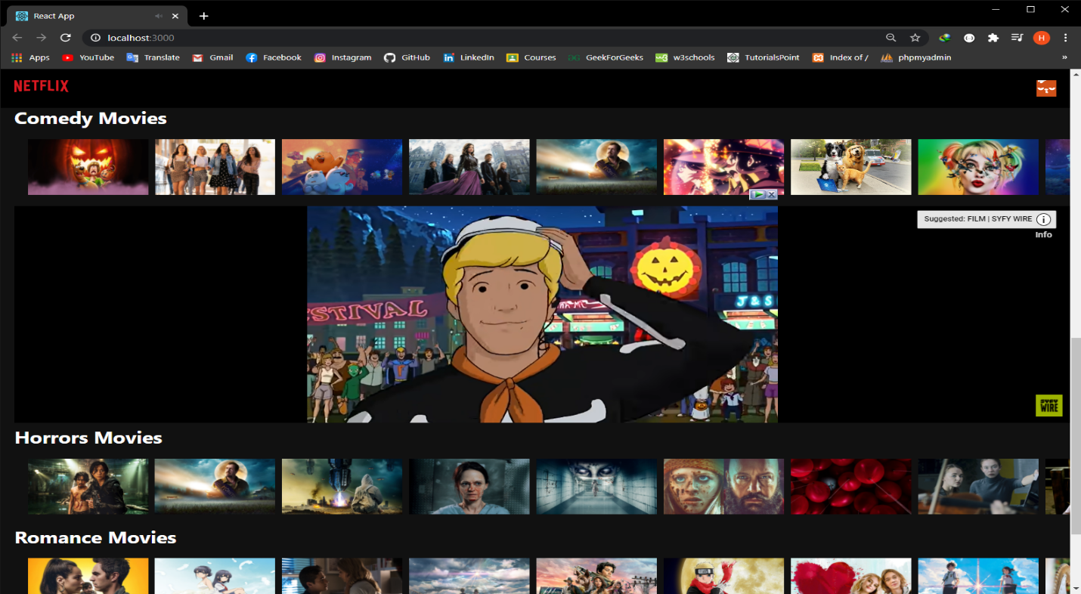

**1-Get TMDB key using their official site , create an account their , then go to API section and get the API Key with a GET Url .**

**2- npx cerate-react-app netflix-clone => to create the app**

**3-Go to firebase and create a new project then go setup the firebase hosting to host our site.**

**4- Click on the web icon on the project overview pages , copy thye npm install firebase.. and past it on the terminal of the project.**

**5- After that go to Hosting section and click get started , and next, next.. . And we have done with Firebase 😊 .**

**6- After creating the react project, we nedd to clean it : Delete**

**App.test.js / logo.svg / setupTests.js**

**7- Go to terminal and install axios : npm i axio .**

**8- Make a file named request.js**

**Their write these code:**

*const API_KEY = “332d0720c319b3390af35287c5548d13”;*

*const request = {*

*fetchTrending: `/trending/all/week/api_key=${API_KEY}&language=en-US`,*

*fetchNetflixOriginals: `/discover/tv?api_key=${API_KEY}&with_networks=213`,*

*fetchTopRated: `/movie/top_rated?api_key=${API_KEY}&language=en-US`,*

*fetchActionMovies: `/discover/movies?api_key=${API_KEY}&with_genres=28`,*

*fetchComedyMovies: `/discover/movies?api_key=${API_KEY}&with_genres=35`,*

*fetchHorrorMovies: `/discover/movies?api_key=${API_KEY}&with_genres=27`,*

*fetchRomanceMovies: `/discover/movies?api_key=${API_KEY}&with_genres=10794`,*

*fetchDocumentariesMovies: `/discover/movies?api_key=${API_KEY}&with_genres=99`,*

*}*

*export default requests;*

**9- Make a file named ‘axios.js’ :**

*Import axios from ‘axios’*

*Const instance = axios.create({*

*baseURL:  «* [*https://api.themoviedb.org/3*](https://api.themoviedb.org/3)*”,*

*});*

*export default instance;*

**The role of this file**

**11- Our App.js will be like this :**

*After im*